CLEAR function for all forms are currently done.
EXIT function also done for all forms.
SCREEN SWITCHING function done.
ADDED CONNECTIONSTRING, JUST NEED TO CREATE PHYSICAL DATABASE AND ADD DATABASE NAME INTO CONNECTIONSTRING SETTINGS

DELETE, SAVE functions are not done. DATABASE CONNECTION not done.
NEED TO CREATE CONFIG FILE , ON MAIN PROJECT KIDDESPORTS APPCONFIG
> CONNECTionSTRINGS in App.Config file in main proj
> <add> tag
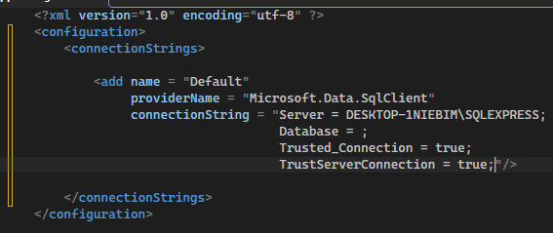
YOU CAN USE .\SQLEXPRESS INSTEAD OF USING THE DEVICE NAME. .\ JUST MEANS LOCAL DEVICE

#region <- USEFUL for big blocks of code to organise
HAVE NOT ADDED FUNCTION FOR EXACT DUPLICATE ENTRIES MANUALLY TYPED IN

